35.32: a) The number of wavelengths is given by the total extra distance traveled, divided by the wavelength, so the number is
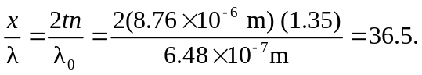
b) The phase difference for the two parts of the light is zero because the path difference is a half-integer multiple of the wavelength and the top surface reflection has a half-cycle phase shift, while the bottom surface does not.

